
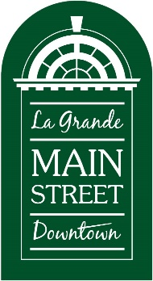
Halloween Safe Trick or Treat
Street Booth Application
Return by October 27, 2024
LGMSD
102 Depot
La Grande, OR 97850
541-963-1223 or 541-805-2820 (cell)

Email to: director@lagrandemainstreet.org
On October 31, 2024, the streets will be closed to traffic on Adams Avenue from 4th to Greenwood and cross-streets for La Grande Main Street Downtown’s Halloween Safe Trick or Treat from 4 – 6:30 PM.

Registration is required of everyone located outside of the closed street section who wishes to have a booth or trunk display for this event. For all downtown businesses, LGMSD members, and all non-profit organizations, participation in this event is free. For businesses located outside of the downtown area who are NOT an LGMSD member, there will be a $25 fee to help cover promotional costs. Please make checks payable to LGMSD.

Plan on having at least 1,500-2,000 kids plus family members who also like candy visit your site!

All participants must arrive and be set up by 3:45 PM on October 31st. The streets will be reopened by 7 PM. Positions will be assigned by LGMSD staff prior to the event.

Name of Business/Organization: ______________________________________

Contact Person Name: ______________________________________________

Signature of Person: ________________________________________________

Phone Number: ___________________________________________________

Email: ___________________________________________________________

